###### IMAGE GALLERY

###### A MINI PROJECT REPORT

###### Submitted by

###### Group: 30

**KESHAV GUPTA, 2410993043,**

**KUSHAN GARG, 2410993053,**

**YASHIT MITTAL, 2410993075,**

###### *in partial fulfillment for the award of degree*

###### *of*

###### 

###### BACHELEOR OF ENGINEERING

***in***

CSE-AI



**CHITKARA UNIVERSITY**

**CHANDIGARH-PATIALA NATIONAL HIGHWAY**

**RAJPURA (PATIALA) PUNJAB-140401 (INDIA)**

###### November 2024

###### TABLE OF CONTENTS

|  |  |  |
| --- | --- | --- |
| Sr.no | **Section** | **Page no** |
| **1.** | Introduction | 3 |
| **2.** | Problem Statement | 4 |
| **3.** | Goals | 5 |
| **4.** | Features | 6 |
| **5.** | Tech Stacks | 7 |
| **6.** | Results | 8-16 |
| **7.** | References | 17 |
| **8.** | Conclusions | 18 |

###### 

**INTRODUCTION**

In today's digital world, images are often more impactful than words, and there is a growing demand for well-organized, visually appealing platforms that allow users to seamlessly share and interact with their visual content. Our Image Gallery Website Project is designed to address this need by offering a full-featured, responsive, and user-friendly experience for uploading, organizing, and sharing images effortlessly.

This platform isn’t just a tool—it’s an opportunity for users to showcase their creativity and storytelling. Photographers can display portfolios to attract clients, designers can present work in an elegant format, and businesses can enhance branding by sharing high-quality visuals. Even casual users can document their life’s moments in a visually compelling way.

Beyond sharing and showcasing, the site encourages interaction and engagement with images. It provides tools for creating narratives around photos, sharing insights, or collaborating with others. This dynamic approach transforms the gallery from a static display to an interactive experience that resonates with audiences.

**PROBLEM STATEMENT**

In today's visually-driven digital era, images have become central to how individuals and businesses communicate, express creativity, and share information. However, the tools available for managing and displaying images online often fall short in addressing the needs of users across a broad spectrum. From casual users to creative professionals, photographers, and businesses, the demand for a **simple, accessible, and secure solution** remains unmet.

**Key Challenges in Current Solutions:**

1. **Simplicity**: Many existing platforms are cluttered or overly complex, making them difficult for non-technical users to navigate and operate effectively.
2. **Customization**: Users often lack the ability to personalize their galleries in a way that reflects their unique style or brand identity.
3. **Searchability and Organization**: Current tools often do not provide advanced categorization, tagging, or search features, leading to time-consuming efforts to locate specific images.
4. **Scope and Functionality**: Limited integration with modern web technologies restricts scalability and advanced functionalities like responsive design, secure sharing, or dynamic content.
5. **Security and Privacy**: Many platforms fail to provide robust security measures, leaving users concerned about unauthorized access to their content.

**GOALS**

Our **Image Gallery Website Project** addresses these challenges by offering a comprehensive platform that is affordable, user-friendly, and rich in features. We prioritize simplicity, customization, security, and scalability to meet the diverse requirements of individuals, businesses, and creative professionals.

**Core Features and Advantages**

1. **Ease of Use**:
   * A straightforward interface ensures that users of all technical levels can upload, organize, and share their images without a steep learning curve.
   * Drag-and-drop functionality, batch uploads, and one-click organization simplify the process further.
2. **Advanced Organization**:
   * Tools like categorization, tagging, and metadata management ensure that images are easily searchable and organized.
   * Users can create custom albums or collections to suit personal or professional needs.
3. **Robust Security and Privacy**:
   * Enhanced security measures, such as encryption, role-based access, and user-defined privacy controls, provide peace of mind.
   * Options for public, private, or restricted access ensure flexibility in sharing content.
4. **Scalability and Modern Features**:
   * Designed to grow with user needs, the platform supports integration with cloud storage, APIs, and emerging technologies like AI-driven tagging and categorization.
   * Dynamic features like interactive carousels, lightboxes, and social media sharing options make galleries engaging.

**FEATURES**

The project caters to a diverse audience, including photographers, designers, businesses, or casual users looking to create personalized or professional online galleries. Built using the latest web technologies, the platform focuses on delivering a seamless and engaging user experience, with features like:

1. **User-Centric Interface**: A clean, intuitive design ensures users can navigate and manage their galleries with ease, regardless of their technical expertise.
2. **Responsive Design**: Fully optimized for all devices, the gallery adapts beautifully to screens of any size, from desktops to smartphones.
3. **Advanced Image Management**: Users can easily upload, categorize, and organize images into albums or collections for streamlined access.
4. **Customizable Galleries**: Personalization features, such as customizable layouts, themes, and display settings, allow users to make their galleries unique.
5. **Secure Sharing Options**: Privacy settings give users control over who can view or interact with their content, making it suitable for both public and private use.
6. **Search and Filter Tools**: Advanced search functionality helps users quickly locate specific images or collections, even in large galleries.
7. **Optimized Performance**: High-quality image compression ensures fast loading times without compromising visual fidelity.

**TECH STACKS**

**HTML Structure of the Web**

HTML forms the backbone of the website, providing the structural layout for all content. It organizes images into grids and galleries, defines elements like headings, paragraphs, and buttons, and structures metadata for SEO. HTML enhances accessibility, enables search engine visibility, and integrates seamlessly with CSS for styling and JavaScript for functionality**.**

**CSS - Designing**

CSS adds visual appeal to the website by styling galleries, grids, and typography. It ensures responsive design for compatibility across devices and incorporates animations and transitions for interactivity. By standardizing styling with reusable rules, CSS creates a cohesive and user-friendly design aligned with the site’s purpose.

**JavaScript - Functionality**

JavaScript adds interactivity and dynamic features to the website. It updates content without page reloads, manipulates HTML elements dynamically, and powers features like sliders, carousels, and filtering. JavaScript enhances user engagement, integrates with backends, and enables modern, responsive web experiences.

**RESULTS WITH EXPLANATION**

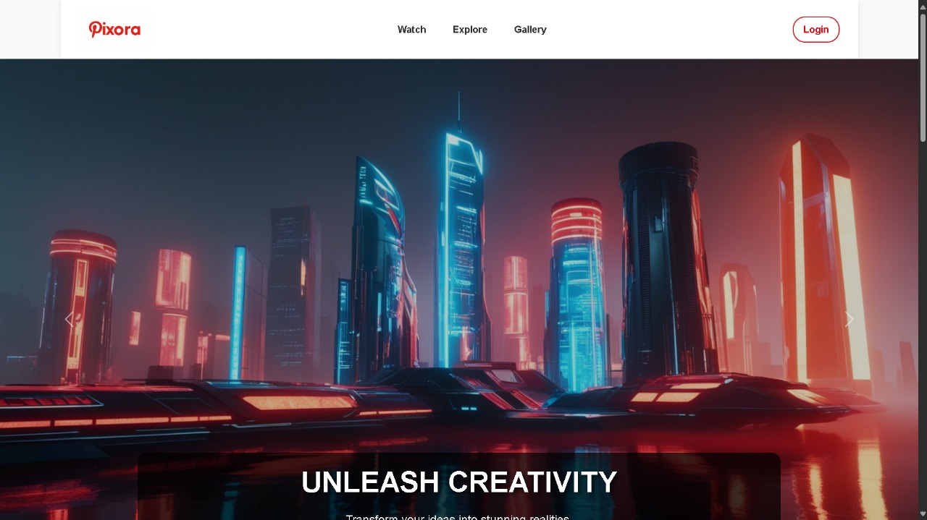

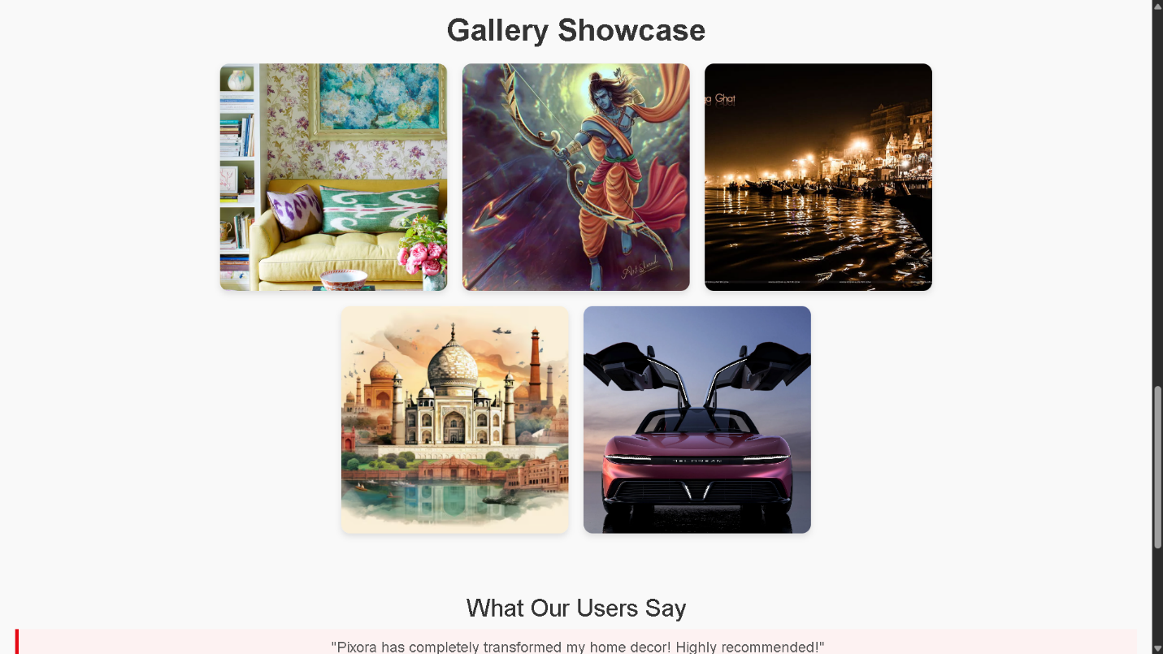

This Pixora landing page introduces users to the platform, which offers an extensive library of free and premium images, videos, and curated galleries.

**LOGIN PAGE**

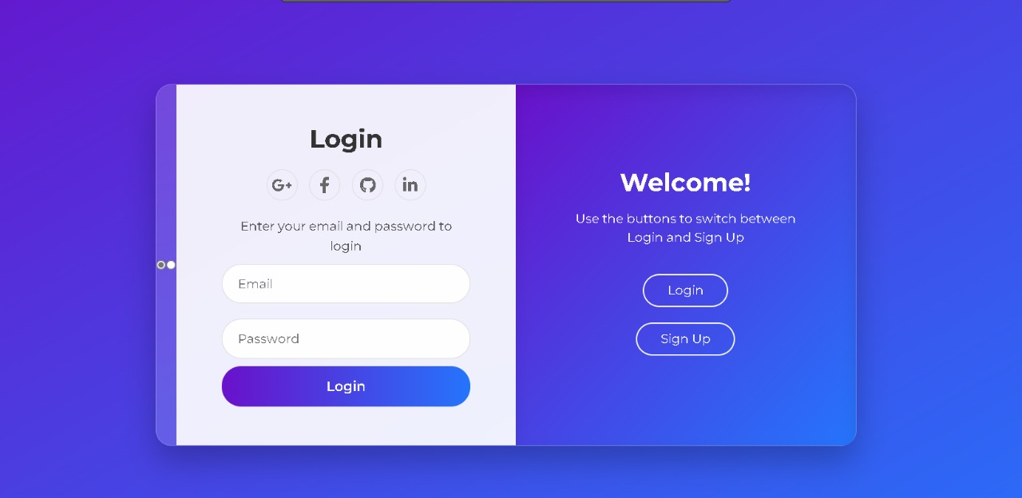

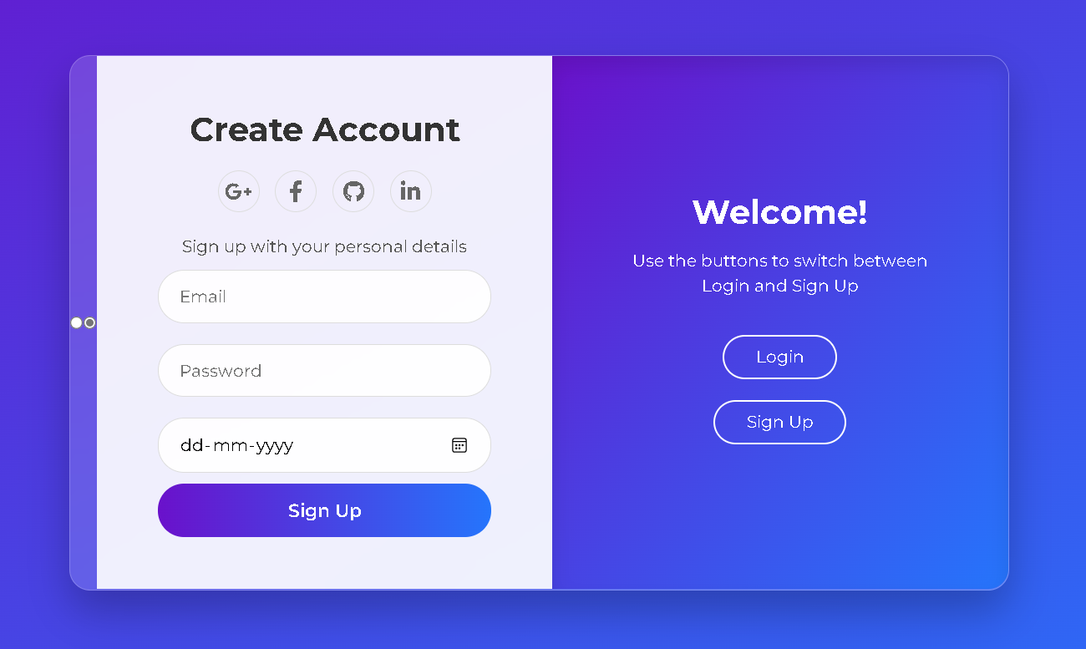

This page is the login and sign-up interface for Pixora. It features a sleek, split-screen design with a vibrant purple-to-blue gradient background.

**WATCH PAGE**

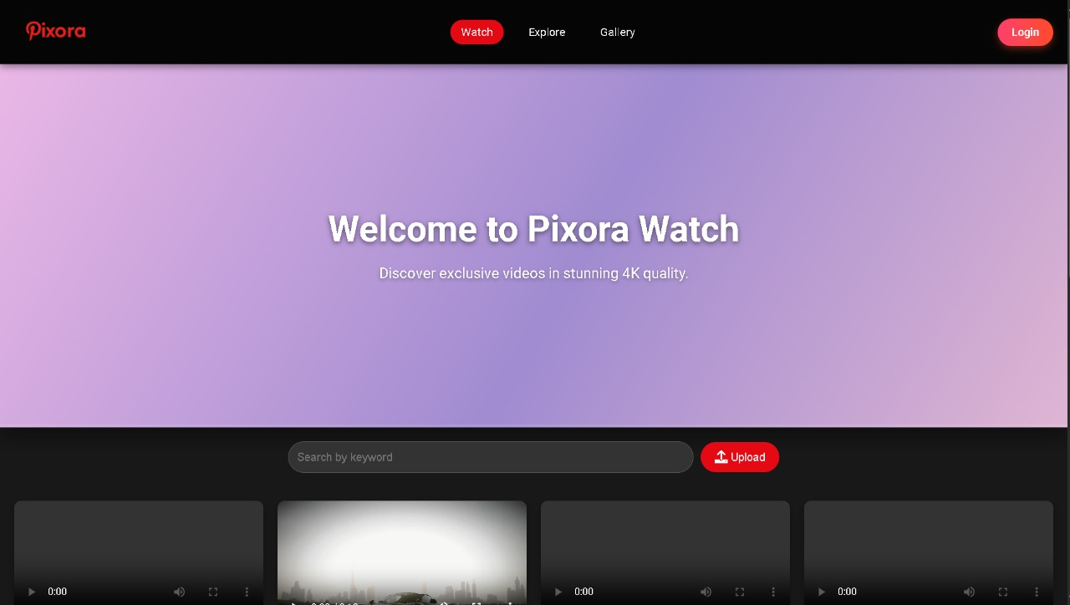

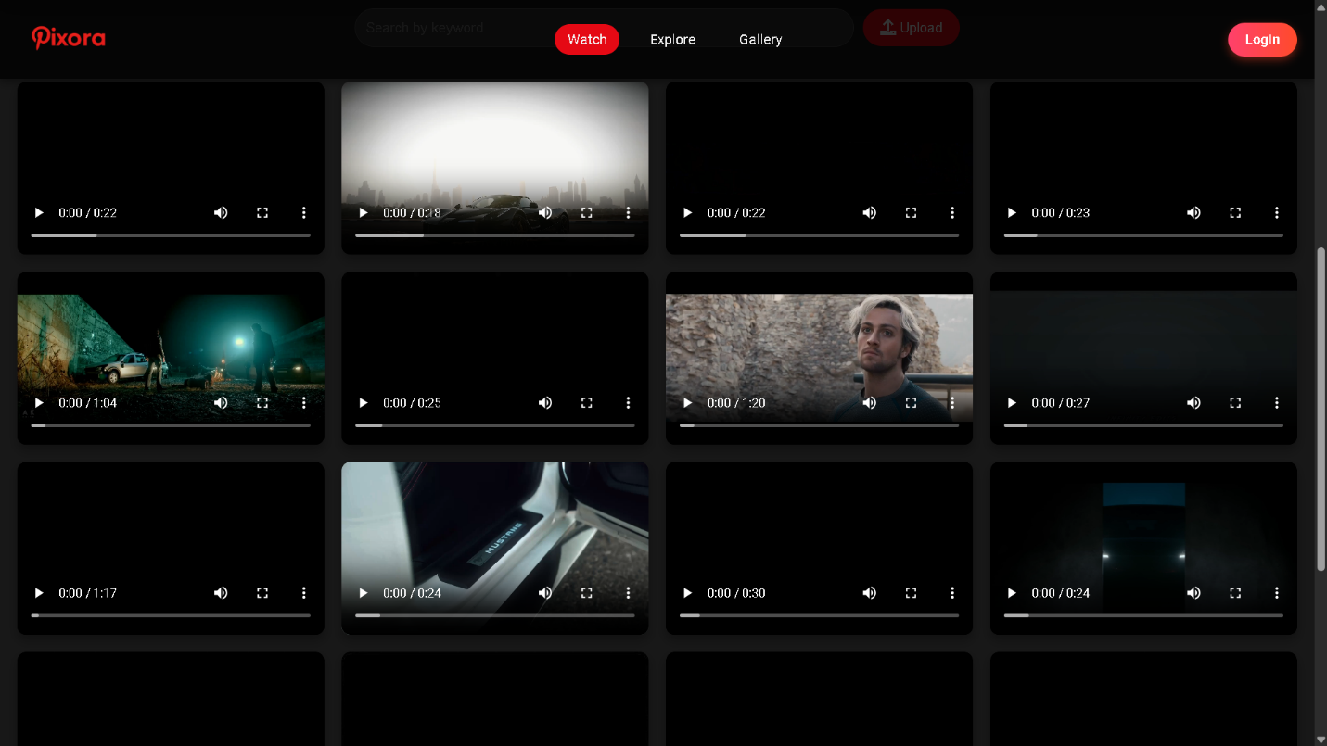

This webpage introduces users to the "Pixora Watch" section, which appears to be dedicated to high-quality video content.

**EXPLORE PAGE**



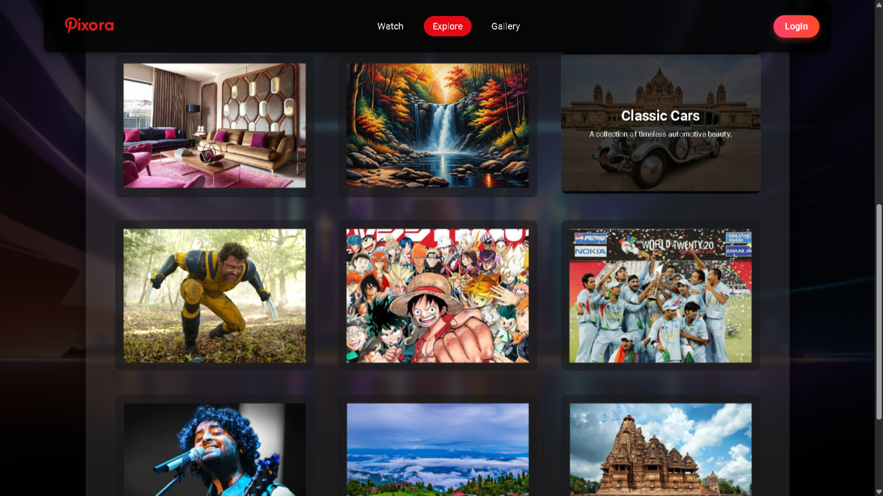

Centered prominently is the text 'WELCOME TO PIXORA' in bold, modern white typography, with the subtitle 'Discover incredible content across various categories' in a sleek, smaller font just below.

**PROFILE PAGE**

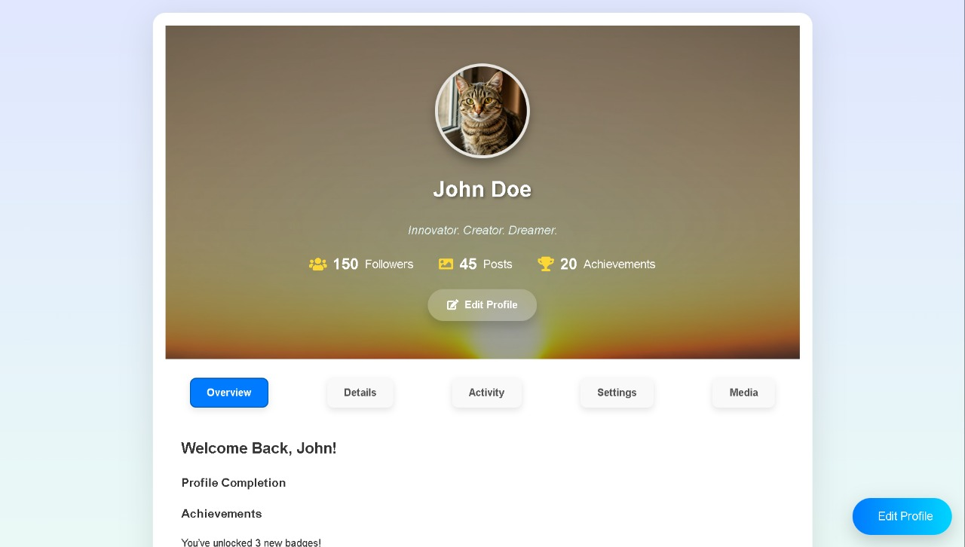

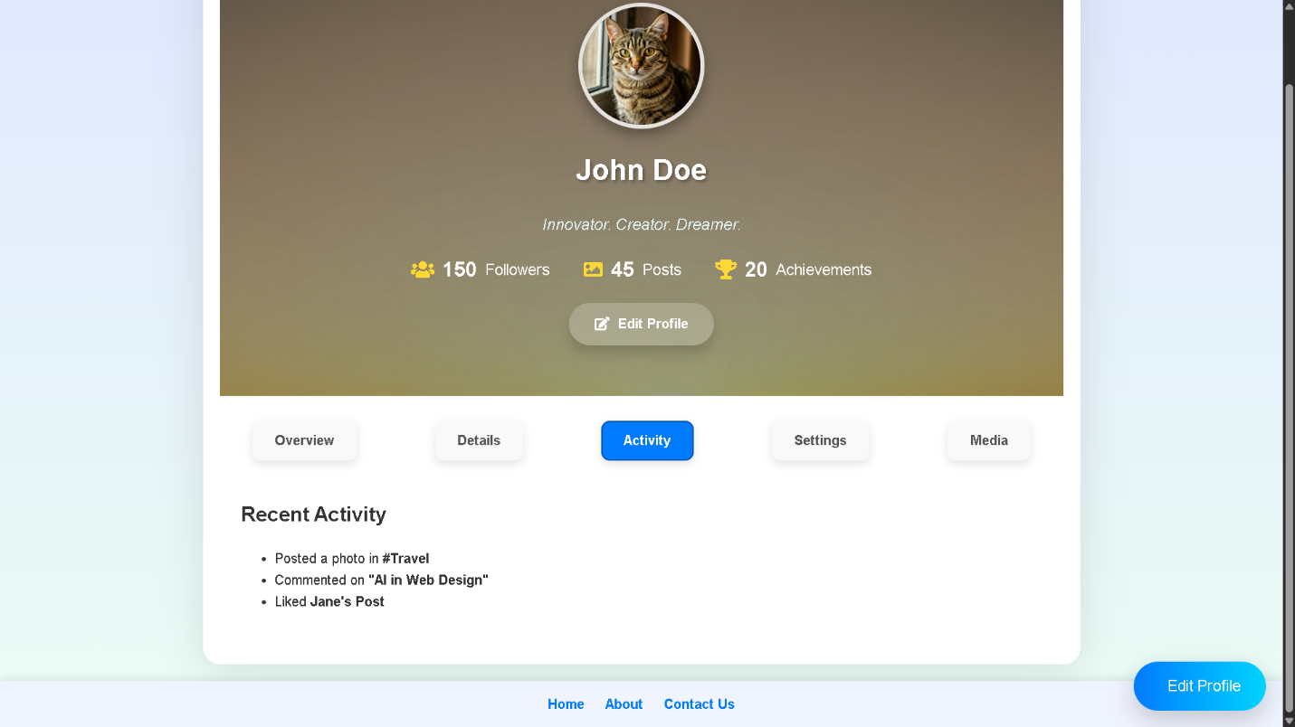

This profile page is thoughtfully designed to provide a comprehensive and interactive user experience.

**GALLERY PAGE**



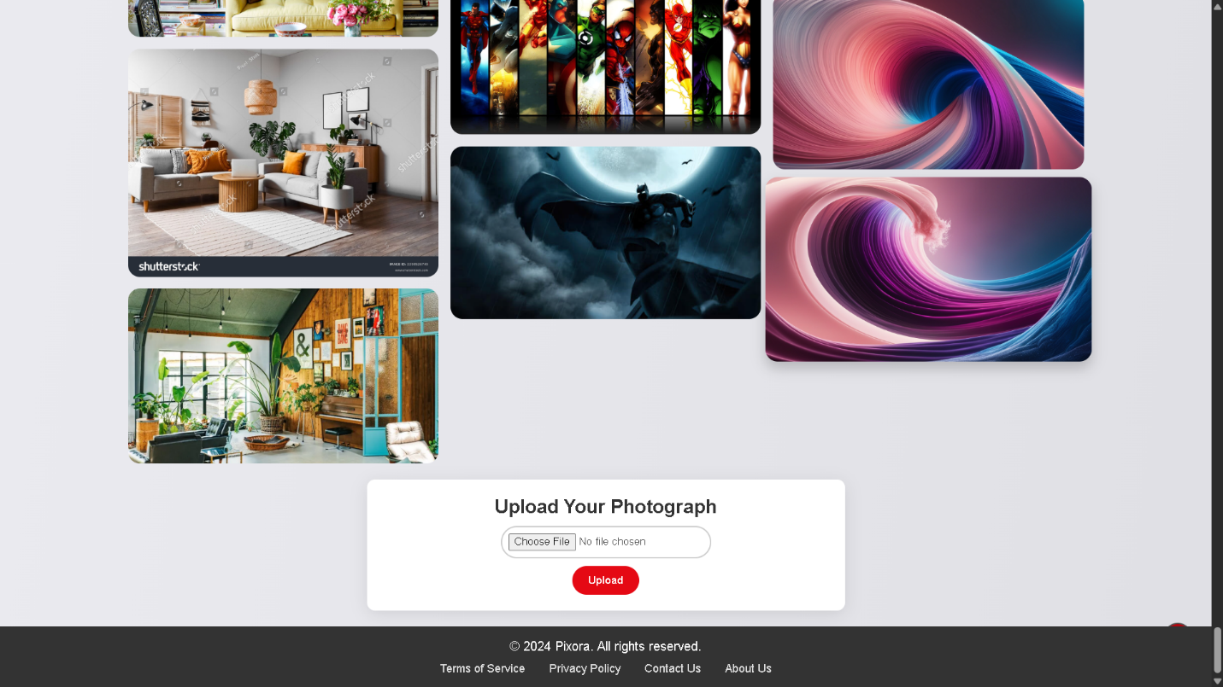

This webpage serves as the entry point to Pixora's "Exclusive Gallery," a section dedicated to showcasing a curated selection of art and cultural imagery.

**ABOUT US PAGE**

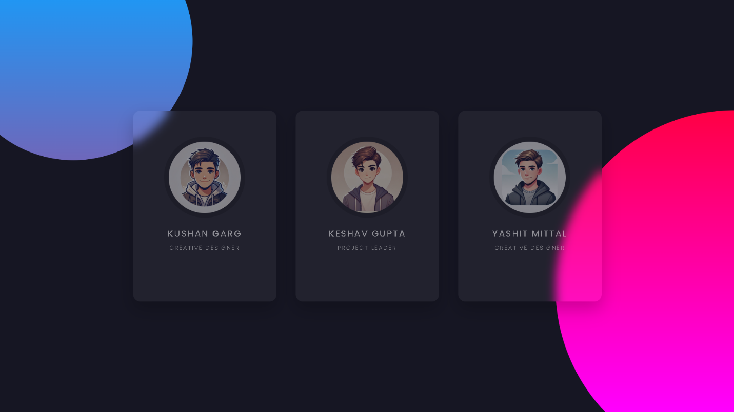

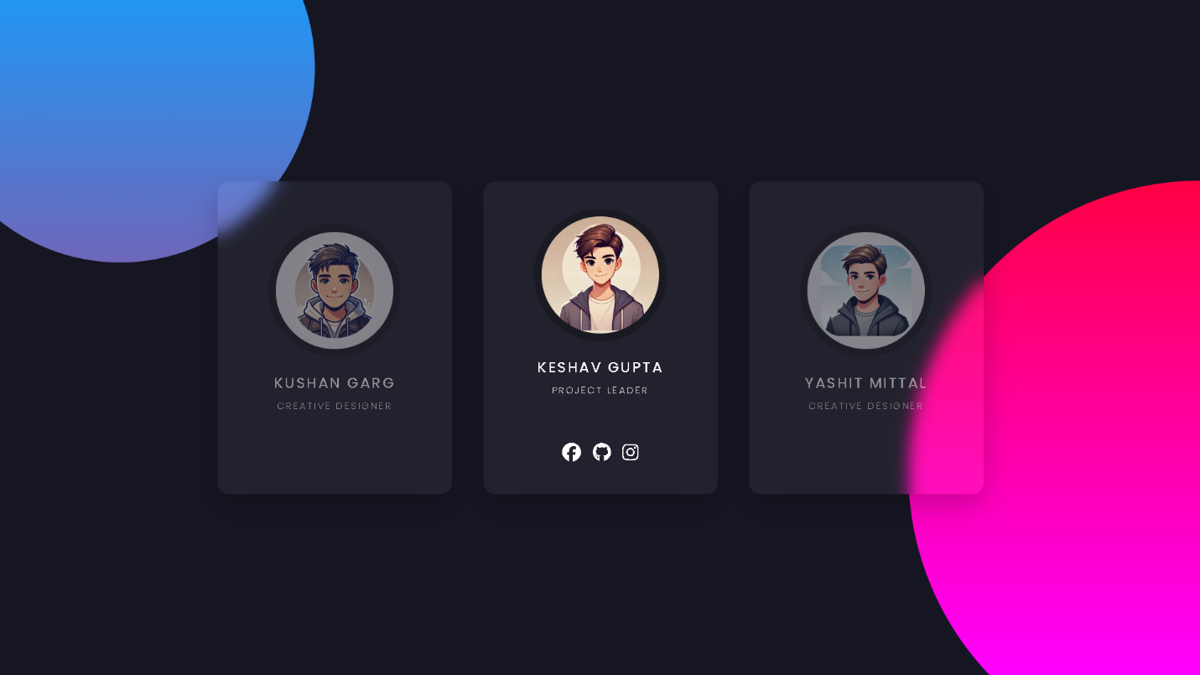

This webpage section appears to be a team introduction or "About Us" panel for Pixora, showcasing three key team members with their roles and stylized avatars.

**TERMS PAGE**

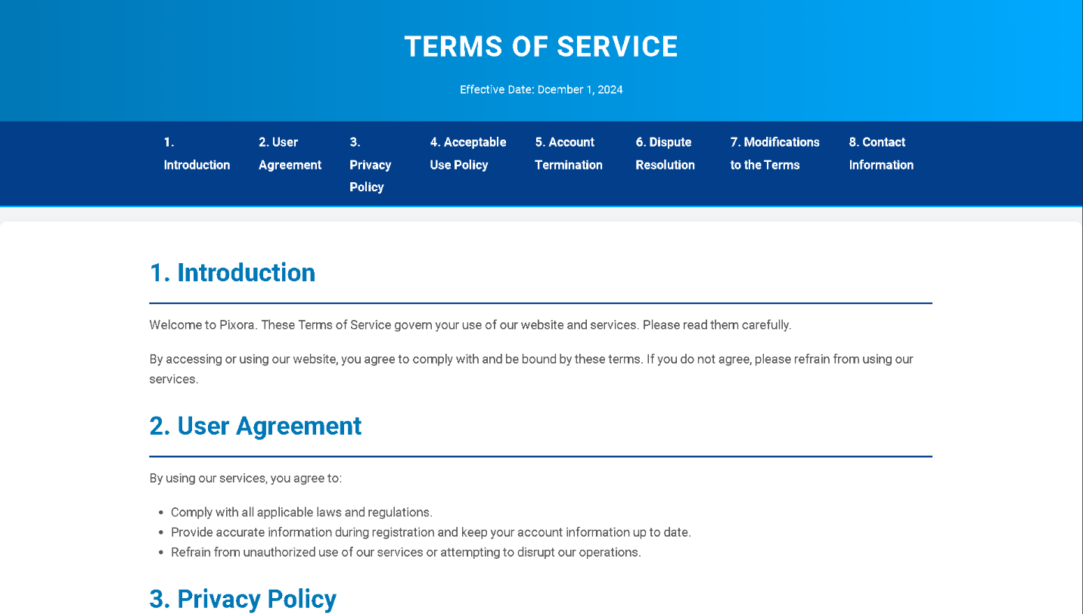

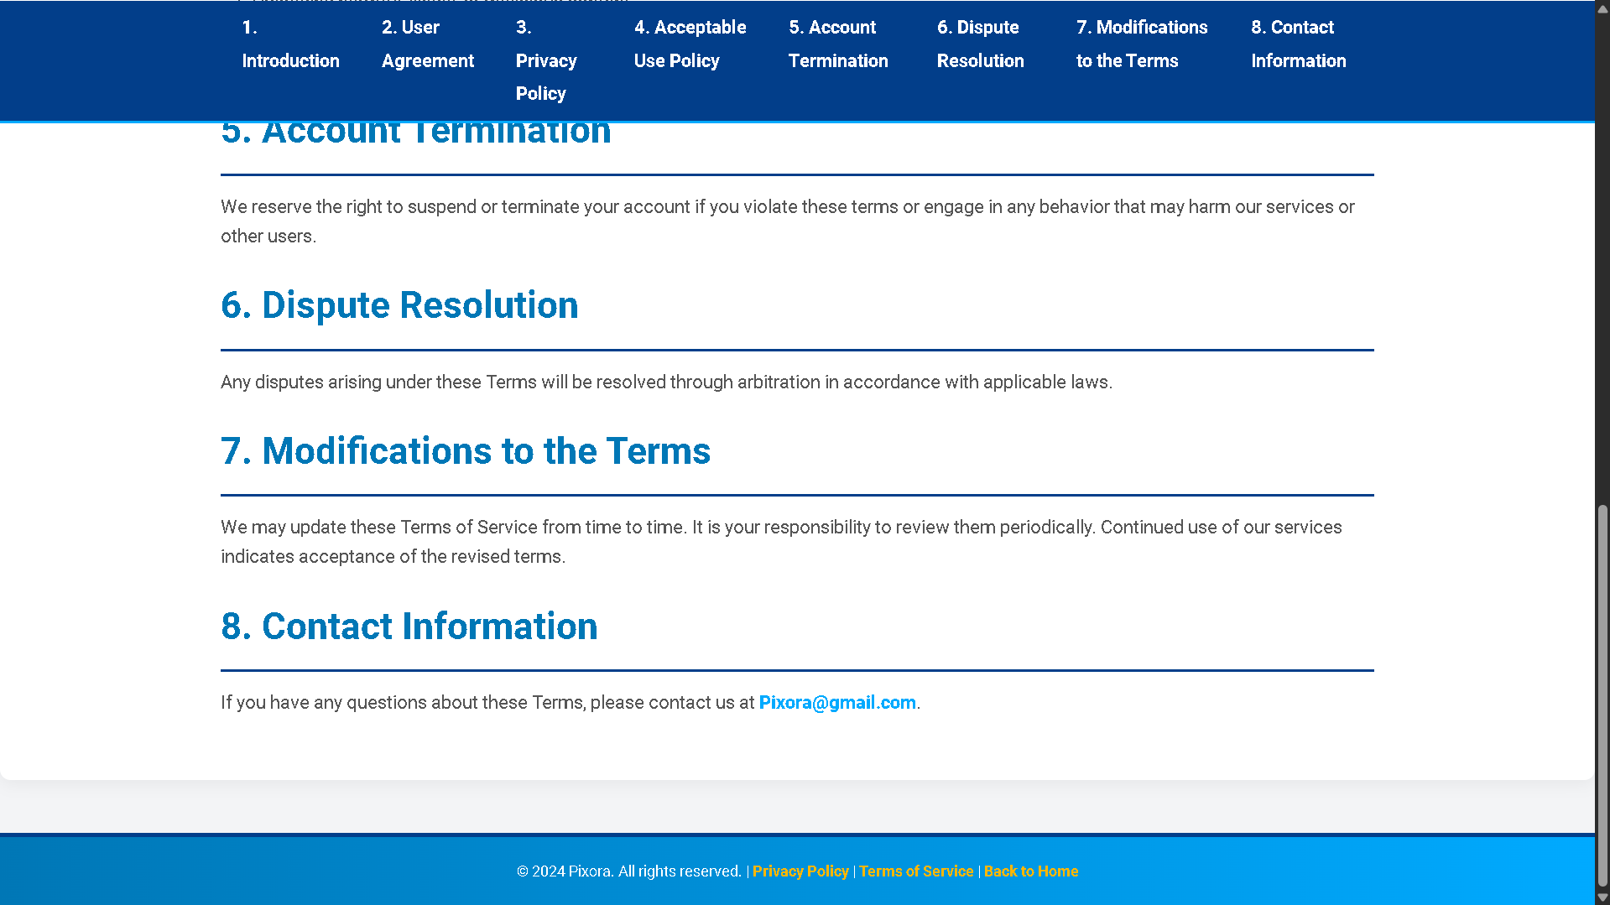

This **Terms of Service** page for **Pixora** outlines the rules users must follow while using the website.

**PRIVACY POLICY**





This **Privacy Policy** page for **Pixora** outlines the platform’s commitment to user privacy and describes how personal information is handled.

**REFRENCES**

Throughout the development of the **Image Gallery Website Project**, various resources were consulted to ensure the implementation of best practices in web development. The following references provided valuable insights and guidance:

**1. Google Search**

Used extensively to gather information, troubleshoot issues, and explore examples of similar projects and best practices for HTML and CSS implementation.

**2. Official Documentation**

**HTML and CSS Documentation:** Resources from MDN Web Docs and W3Schools were consulted for best practices, coding standards, and technical explanations.

**3. AI Models**  
Insights were derived from AI-based tools to assist in code generation, image optimization suggestions, and design enhancements.

**4. YouTube Videos**  
Tutorials from various YouTube channels provided in-depth explanations and examples of responsive design, CSS animations, and interactive elements.

**5. Pinterest Official Website**  
Design inspiration for layout and image grid styles was drawn from the Pinterest platform, helping guide visual elements and UI/UX principles for the gallery structure.

**CONCLUSIONS**

The **Image Gallery Website Project** is a comprehensive platform designed to make managing, showcasing, and sharing images simple and efficient. Catering to photographers, artists, businesses, and casual users, it combines ease of use with powerful tools for organizing and presenting visual content. By focusing on effective navigation, modern design, and robust functionality, the platform meets the growing demand for a versatile and professional image management system.

At its core, the project embodies a seamless integration of design, technology, and user experience. The intuitive interface ensures accessibility for all users, while advanced features like customizable galleries, secure sharing options, and responsive design provide flexibility and scalability. Whether creating personal photo albums, professional portfolios, or business showcases, the platform offers an adaptable solution for a variety of needs.

With a commitment to **sustainable development**, the platform evolves over time, incorporating new features and improvements to enhance its value and relevance. Future-ready integrations, such as AI-driven tagging, cloud storage, and collaborative tools, ensure a cutting-edge user experience. By prioritizing innovation and scalability, the **Image Gallery Website Project** empowers users to share their visual narratives with style, confidence, and ease.